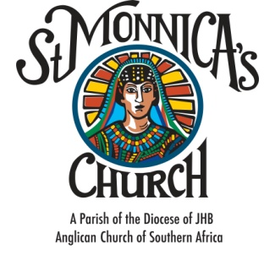

CONFIRMATION APPLICATION FORM - YOUTH
YEAR:
PARTICULARS OF CANDIDATE
Identity/Passport No:

Church Membership No:

Surname:

First Names:

Gender: | Male |  |  | Female |  |  | Date of Birth: |  | d | d | / | m | m | / | Y | Y | Y | Y
Cell No: |  |  |  |  |  | Email:

Baptised? | Yes |  |  | No |  | Date of Baptism: | d | d | / | m | m | / | Y | Y | Y | Y

Church where baptised:

Signature: |  |  | Date:
PARTICULARS OF FATHER
Identity/Passport No:

Church Membership No:

Surname: |  | First Names:

Residential Address:

Mobile No: |  |  | Email:

Are you baptised? | Yes |  |  | No |  |  | Are you confirmed? | Yes |  |  | No

Signature: |  |  | Date:

PARTICULARS OF MOTHER
Identity/Passport No:

Church Membership No:

Surname:

First Names:

Residential Address:

Mobile No: |  |  | Email:

Are you baptised? | Yes |  |  | No |  |  | Are you confirmed? | Yes |  |  | No

Signature: |  |  | Date:

Required Documentations:
Submitted
Certified copy of Unabridged Birth Certificate
Copy of Baptism Certificate

FOR OFFICE USE ONLY

Date of application submission: |  | Commencement of Classes:

Facilitator Name: |  |  | Date of Service:
Rector’s Confirmation Authorisation:
Name |  | Signature |  | Date

