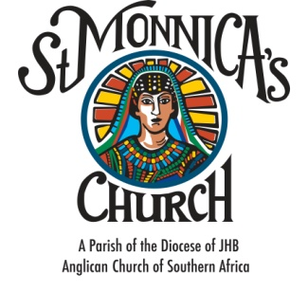

CONFIRMATION APPLICATION FORM
ADULT CANDIDATE
YEAR ______

PARTICULARS OF CANDIDATE

- Identity number

- Church Membership Number: ______________
- Surname: ____________________________________________________________________________________________________________
- Christian names: ______________________________________________________________________________________________________
- Gender: Male/ Female

- Cell: __________________________________________________________
- Email: _________________________________________________________
- Occupation: ____________________________________________________
- Has the candidate been baptized? ____________________________
- Date of Baptism: __________________________________________
- Church: __________________________________________________

Candidate signature _______________________________ Date ___________________________
Required Documentation:
- Copy of Identity Document/ Passport
- Copy of Baptism Certificate

FOR OFFICE USE
CONFIRMATION PROCESS
DETAILS | STATUS | DATE
- Spiritual Formation
- Enrichment Class
- Retreat/ Quiet Day
** NOTE: Candidates are required to attend at least 90% of formation classes
CHECKLIST
DETAILS | STATUS | DATE
- Application Form Submission
- Required Documents Submission
- Confirmation Register Completed
- Dummy Certificate
- Final Certificate printing
- Bishop Certificate signing
- Diocesan form entry
- Filing of documentation

Facilitator’s Name: ________________________________________________________
Confirmation Date: ________________________________________________________

Rector’s Confirmation Authorization:

______________________ ______________________ ____________________
Name Signature Date

