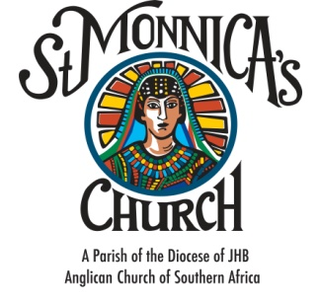

ALPHA MARRIAGE COURSE APPLICATION
YEAR ______
PARTICULARS OF COUPLE
- Identity number

- Church Denomination: __________________________________

- Church Membership Number (Member of St Monnica’s Anglican Church): ______________
- Surname: __________________________________________________________________________________________________________
- Christian names: ______________________________________________________________________________________________________
- Permanent residential address: _______________________________________________________________________________________
_______________________________________________________________________________________
- Cellphone Number: ____________________________
- Email Address: ________________________________________________________
- Occupation: __________________________________________________________
- Telephone Number (W): ________________________________________________

- Identity number

- Church Denomination: __________________________________

- Church Membership Number (Member of St Monnica’s Anglican Church): ______________
- Surname: ____________________________________________________________________________________________________________
- Christian names: ______________________________________________________________________________________________________
- Permanent residential address: _______________________________________________________________________________________
_______________________________________________________________________________________
- Cellphone Number: ____________________________
- Email Address: ________________________________________________________
- Occupation: __________________________________________________________
- Telephone Number (W): ________________________________________________

